# Brainstorming

* ~~Three (3) documented brainstormed ideas~~

Dog feeder

Watch that detects if someone got under their set goal of steps

Website for volunteers (organizing and more)

## Purpose statement

* ~~A documented specific purpose statement that is no more than 2 sentences and includes the follow, at minimum: - What is being made - Why it is being created - Who will be using it~~

This is a system that can detect when a door has been opened and to protect. It is being created so that everyone can use it including families, children, companies, and much more.

### Research

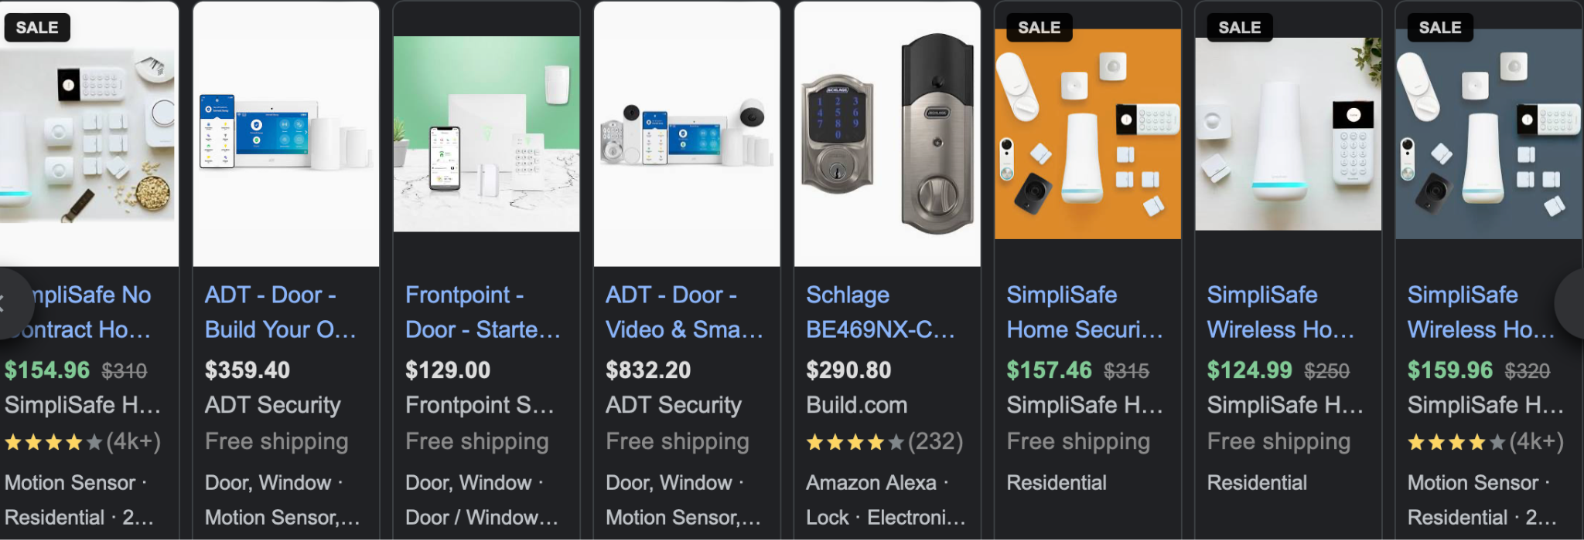

Typically $$$$

Have it connect to all devices that are connected to the internet (they will receive a notification)

<https://www.security.org/home-security-systems/do-i-need-one/>

Out of 127.59 million households in the United States, only 36 million have home security systems,

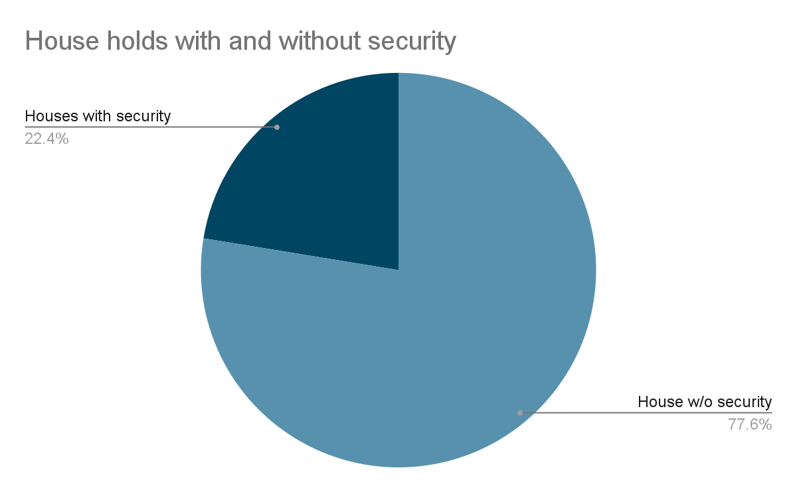

Benefits

As the number of home security systems increased in an area, the number of residential robberies decreased in that area, even for people who didn’t have their own security system. Having a security system not only protects you, but helps deter crime and creates a safer neighborhood for everyone.

but having the system in your home can lower your homeowner’s insurance by up to 20%.

The sense of security and comfort you gain with an alarm system is perhaps the greatest benefit of all. Next to being safe, the confidence of feeling safe will help you be a more productive, healthy, and focused person.

